Linked Hash Set->

\*1.4v

\*child class of HashSet.

\*Linked Hash Set where duplicates not allowed.but insertion order preserved.

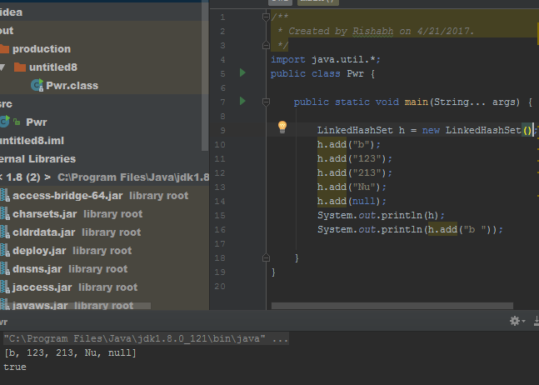

Cache based application->

We use Linkedhashset becuz we don’t want duplicates

But insertion must preserved.